Installation of the IP_Tools Addin:  
1. Double click on the installer file "setup_iptools.msi""

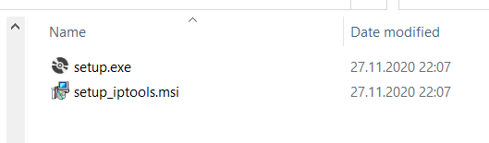

2. Choose the directory where you want the addin to be installed to. Here, it is

"C:\Program Files (x86)\Default Company Name\setup_iptools\"

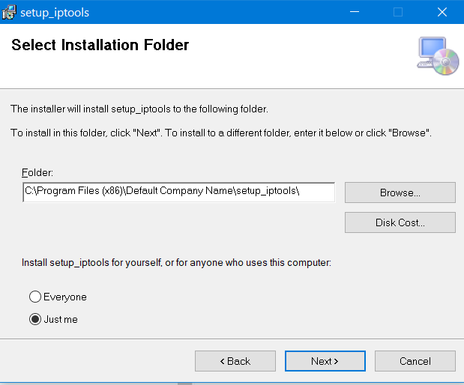

3. Go to that directory and double click on iptools.vsto

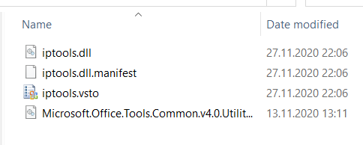

4. Confirm the installation of the addin

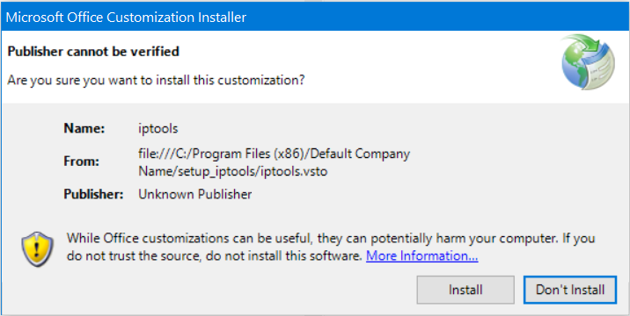

After that the installation process is completed and when Word is started, a new menu group "IPTools" will appear under the Menu item "AddIns". When the button "Number Paragraphs" is pressed, a Window will be loaded, which provides the paragraph numbering functions.

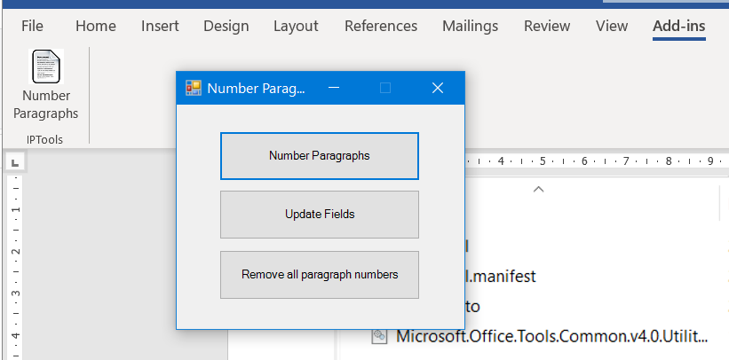

De-Installation of the IPTools Addin:  
Type "Add or Remove Programs" into the Windows search field. Search for "iptool" in the search field of the "Add or Remove Programs" menu. Then uninstall iptools and setup_iptools by pressing the respective "uninstall" buttons.

